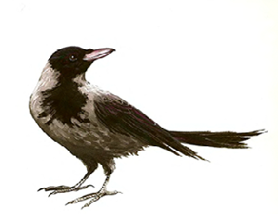

5

|  |  |
| --- | --- |
|  |  |
|  |  |

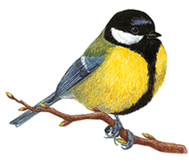

8

|  |  |
| --- | --- |
|  |  |
|  |  |
|  |  |
|  |  |

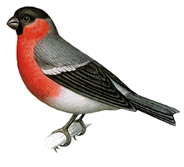

7

|  |  |
| --- | --- |
|  |  |
|  |  |
|  |  |

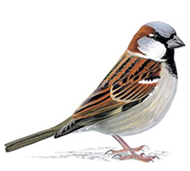

6

|  |  |
| --- | --- |
|  |  |
|  |  |
|  |  |

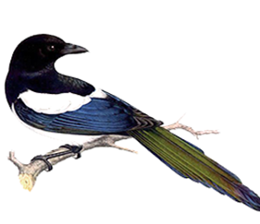

9

|  |  |
| --- | --- |
|  |  |
|  |  |
|  |  |
|  |  |



    
    
    
    
    
    